

**School of Computer Science and Engineering**

**Job Fit Analyzer**

*A project submitted*

*in partial fulfilment of the requirements for the degree of*

*Bachelor of Technology in Computer Science and Engineering*

**By**

|  |  |
| --- | --- |
| Jaini Karthik | (21BCE5376) |
| Pardha Saradhi Raju | (21BCE5634) |
| Rajamalla Ananya Tej | (21BCE5855) |
| Shaik Ashfaaq Hamja | (21BCE1690) |
| Potnuru Jayanth | (21BCE1037) |
|  |  |

**Course Instructor**

Dr. Radha R

Professor

**April 2022**

**UNDERTAKING**

This is to declare that the project entitled “Job Fit Analyzer” is an original work done by undersigned, in partial fulfilment of the requirements for the degree “Bachelor of Technology in Computer Science and Engineering” at School of Computer Science and Engineering, Vellore Institute of Technology (VIT), Vellore.

|  |  |  |  |
| --- | --- | --- | --- |
| Jaini Karthik | | | (21BCE5376) |
| Pardha Saradhi Raju | | | (21BCE5634) |
| Rajamalla Ananya Tej | | | (21BCE5855) |
| Shaik Ashfaaq Hamja | | | (21BCE1690) |
| Potnuru Jayanth | | | (21BCE1037) |
|  | |  |

All the analysis, design and system development have been accomplished by the undersigned. Moreover, this project has not been submitted to any other college or University.

## 

## ABSTRACT

The job recruitment process takes a lot of time and resources as not only one job fit analyzer is involved but a different variety of people are needed for smooth functioning. One of the major tasks of a recruitment process is the first sorting and filtering of candidates. Different organisations and job profiles require different qualities that are best suited for that role. Organisations spend a great deal of time screening potential candidates, in light of their character, that best suits their needs.

With our project Job Fit Analyzer, we mean to give a simple yet effective method for the initial screening of candidates by breaking down their scores on psychometric tests and questionnaires. The tests will decide the scores of different character tests dependent on the Big Five Model and MBTI Personality Traits.

We aim to analyse the questionnaire filled by an applicant and then score them based on the responses. These scores are transferred to our AI Model which helps to classify the applicant based on his/her most relevant character trait. Then the recruiter can filter his potential candidate based on the character traits he needs to fulfil his job requirement.

**TABLE OF CONTENTS**

**CONTENTS Page No.**

**Abstract** **2**

**1 Introduction** **4**

1.1 Objective 4

1.2 Project Scope 4

1.3 Definitions 4

**2 Literature Survey** **6**

**3 Proposed Methodology** **11**

**4 Architecture/Design** **12**

1.1 Overview 12

1.2 System Architecture 13

1.3 Components Description 13

**5 Description of Various Modules** **17**

**6 Implementation (Sample Code)** **18**

**7 Testing (ALL Screen Snapshots)** **27**

7.1 Phase 1 Comparison of Various Models 27

7.2 Phase 2 Implementation of the Chosen Model 30

7.3 Test cases 31

**8 Conclusion and Future Enhancements** 43

**References** 43

# 

# 1. Introduction

## 1.1 Objective

The fundamental objective of our project is to provide an efficient screening system for the companies to recruit manpower resources. Our model will help the companies to sort their job applicants based on an analysis of scores of psychometric tests and questionnaires. Our main objectives are to help the job recruiters to categorise their candidates based on tests, questionnaires and resumes and make it effortless for an organisation to fasten their enlistment process.

This would help them with picking the most reasonable up-and-comer in less time for which we will provide a software/model for the recruiter to ease this process and also to the job seekers to analyse their resume and build their resume under the requirements.

## 1.2 Project Scope

There's a very rigorous screening process for pre-interview rounds and still aren't as accurate as it should be. Most of the time this results in vagueness in selections. Our project comes into play in situations like these. Our website provides a set of curated questions to judge the applicant based on Big 5 Factors namely - Openness, Conscientiousness, Extraversion, Agreeableness and Neuroticism. These factors help in accurately determining an applicant's dominant personality. The website also provides an efficient way for recruiters to log in and filter through the applicants. Easing the job for both the applicants and recruiter.

## 1.3 Definitions

### Logistic Regression

When the dependent variable is dichotomous, logistic regression is the appropriate regression analysis to use (binary). The logistic regression, like all regression analyses, is a predictive analysis. Logistic regression is a data analysis technique that is used to describe and explain the relationship between one dependent binary variable and one or more nominal, ordinal, interval, or ratio-level independent variables.

### Big 5 OCEAN

Personality Traits Openness, Conscientiousness, Extroversion, Agreeableness, and Neuroticism are the five major personality traits, also known as OCEAN and CANOE. These five characteristics represent broad domains of human behaviour and account for differences in personality as well as decision making. Today, HR professionals use the model to evaluate potential employees, and marketers use it to understand their product's target audiences. By the 1990s, it was widely accepted that situational and personality factors both influence in-the-moment behaviour. Even as recently as 2016, research and refinement of the OCEAN model were ongoing, demonstrating how influential it is — and continues to be.

### The Big Five Personality Traits

**Openness to experienc**e: also known as intelligence or imagination, this trait denotes a willingness to try new things and think outside the box. Insightfulness, originality, and curiosity are all characteristics.

**Conscientiousness**: the desire to be cautious, diligent, and self-disciplined in regulating immediate gratification Characteristics include ambition, discipline, consistency, and dependability.

**Extroversion**: as opposed to being alone, a state in which an individual draws energy from others and seeks social connections or interaction (introversion). Characteristics include being outgoing, energetic, and self-assured.

**Agreeableness**: the assessment of how an individual interacts with others, as measured by compassion and cooperation Tactics, kindness, and loyalty are examples of characteristics.

**Neuroticism**: a proclivity for negative personality traits, emotional instability, and self-destructive thought Pessimism, anxiety, insecurity, and fearfulness are all characteristics.

# 2. Literature Survey

|  |  |  |  |  |  |
| --- | --- | --- | --- | --- | --- |
| **S.**  **No** | **Title and**  **Year** | **Algorithm**  **Used** | **Dataset being used** | **Performance**  **Measures** | **Gap**  **Identified** |
| 1 | **Personality**  **Predictions**  **Based on**  **User Behaviour on the Facebook**  **Social**  **Media**  **Platform October**  **2018** | Logistic  Regression,  Gradient  Boosting,  Support  Vector  Machine and  XGBoost | myPersonality dataset (250 users and 9917 status updates) | Accuracy = (correct predictions/total  prediction) *  100 | Analyses social media behaviour which could be misleading |
| 2 | **Personality**  **Prediction**  **System**  **Based on**  **Signatures**  **Using**  **Machine**  **Learning 2020** | Support  Vector  Machine | Digital Image | Confusion Matrix | Analyses signatures which is not the best basis for personality prediction |
| 3 | **Personality**  **Prediction from**  **social**  **media**  **Text: An**  **Overview**  **- May** **2020** | KNN, SVM,  LSTM,  CNN,  TF-IDF  Bayes,  XGBoost | 1. 2467 essay stagged with their author’s   traits   1. Short text of YouTube vloggers | Classification Reports | Analyses social media behaviour which could be misleading |
| 4 | **Personality**  **Evaluation and CV Analysis using**  **Machine**  **Learning**  **Algorithm –**  **May 2019** | TF-IDF | User  Collected  Data | Not Specified | Words can have  different  meanings in different  contexts, hence scoring |
|  |  |  |  |  | words could be misleading |

|  |  |  |  |  |  |
| --- | --- | --- | --- | --- | --- |
| 5 | **Automated**  **Personality**  **Classification Using Data**  **Mining**  **Techniques -**  **April 2017** | Advanced  Naive-Bayes  Classification Algorithm,  Support  Vector  Machine | User Collected Data | Not Specified | Does not implement  DL  algorithms such as  XGBoost, etc. And does not implement the Big 5 factor. |
| 6 | **Big Five**  **Factor**  **Model,**  **Theory and**  **Structure 2015** | OCEAN | NA | NA | Being Implemented |
| 7 | **A study on the effect of big five**  **personality**  **traits on emotional intelligence - 2014** | OCEAN | NA | NA | Being Implemented |
| 8 | **A Study of the Effect of the**  **Myers**  **Briggs**  **Type**  **Indicator on Team Effectiveness - 2003** | ISTJ, ISFJ, INFJ, etc | NA | NA | Does not implement into the program. |
| 9 | **Random**  **Forests and**  **Decision**  **Trees -**  **2012** | J.48, C4.5 algorithm | UCI Machine Learning repository, Dataset  Lymphography, Dataset  Sonar, | Classification Report | Does not implement into the program. |

|  |  |  |  |  |  |
| --- | --- | --- | --- | --- | --- |
|  |  |  | Dataset  Heart-h |  |  |
| 10 | **Workshop**  **on Support Vector Machines: Theory and**  **Application s - 2001** | Support  Vector  Machine  (SVM) | set of l training data {(x1, y1) ...  (xl, yl)} in Rn × R sampled according to unknown  probability distribution P (x, y), and a loss function V (y, f(x)) | Not Specified | Being Implemented |
| 11 | **KNN**  **Model**  **Based Approach**  **in**  **Classification - 2004** | KNN | UCI machine learning repository | Classification  Accuracy and  Reduction Rate | Being Implemented |
| 12 | **A KNN**  **Research**  **Paper**  **Classification Method**  **Based on**  **Shared**  **Nearest**  **Neighbour 2010** | KNN | Millions of training sets in about 400  subclasses, 6000 Main groups,  30000 subgroups | Precision | Being Implemented |
| 13 | **An**  **Introduction to Logistic Regression**  **Analysis and**  **Reporting 2002** | Logistic  Regression | Sample Data for Gender and Recommendation for Remedial Reading  Instruction, 189  Children’s  Referrals for  Remedial  Reading  Programs by  SAS PROC  LOGISTIC | Classification  Accuracy | Being Implemented |

|  |  |  |  |  |  |
| --- | --- | --- | --- | --- | --- |
| 14 | **Long**  **Short -**  **Term**  **Memory 1997** | RNN, LSTM | Not Specified | Classification  Accuracy | Not Implemented |
| 15 | **Creating**  **Crowd**  **Variation with the**  **OCEAN**  **Personality Model - 2008** | OCEAN | NA | NA | Being Implemented |
| 16 | **How the**  **Ocean**  **Personality Model Affects the Perception of Crowds**  **- 2011** | OCEAN | NA | NA | Being Implemented |
| 17 | **A logistic regression**  **investigation of the relationship between**  **the learning Assistant**  **model and**  **failure rates in**  **introductory**  **STEM**  **courses -**  **2018** | |  |  | | --- | --- | | Logistic |  | | Regression | | | Admin records at the  University of Colorado Boulder.  Focuses on 16 cohorts of students who entered the university as full-time freshmen for each fall semester from 2001 to 2016 and took  Physics I/II,  General  Chemistry I/II, Calculus I/II,  and/or Calculus  I/II for  Engineers. | Not Mentioned | Being Implemented |

|  |  |  |  |  |  |
| --- | --- | --- | --- | --- | --- |
| 18 | **Binary**  **Logistic Regression**  **Analysis in**  **Assessment**  **and**  **Identifying Factors**  **That**  **Influence**  **Students’**  **Academic Achievement 2016** | Logistic  Regression | Questionnaire and checklist were designed to collect data by distributing to students. | Not Mentioned | Being Implemented |
| 19 | **A Survey of the Big Five**  **Personality**  **Traits**  **Among**  **Elementary Teachers-2017** | OCEAN | NA | NA | Being Implemented |
| 20 | **XGBoost**  **Based**  **Algorithm Interpretation and**  **Application on**  **Post-Fault**  **Transient**  **Stability**  **Status Prediction of Power System 2019** | XGBoost | PMU Data | Classification accuracy | Being Implemented |
| 21 | **Efficient**  **Way Of**  **Web**  **Development Using Python And Flask. - 2015** | Flask Module | NA | NA | Being Implemented |
| 25 | **Gradient**  **Boosting Machines, a tutorial** | Gradient  Boosting  GBM | An artificially generated dataset | RMSE | Not implemented |

# 

# 3. Proposed Methodology

### 4.1 Drawbacks of Existing Systems

The existing work on Personality Prediction is on analysing social media behaviours, analysing signatures or handwriting, etc. These methods tend to be erroneous as people depict a different character on social media altogether. And the handwriting is not an ideal way to judge someone’s personality. Also, some systems analyse the applicant’s CV (or Resume). These tend to be slightly erroneous too as the context of the word can vary from one CV to another. None of the existing systems uses any verified or highly tested ways of identifying one’s personality. Moreover, personality prediction in the recruitment process is not explored much.

### 4.2 Our Solution

Our system will provide a Questionnaire that would score their five personality tests based on the Big Five Model - OCEAN (Openness, Conscientiousness, Extraversion, Agreeableness,

Neuroticism). Then based on the score, the model will predict the personality of the person.

In the first stage of the development, we will train our model based on various algorithms like KNN, SVM, Logistic Regression and XGBoost. Then we will compare the precision of our model for each model using data visualization and some metrics like confusion matrix and classification report.

Considering the results from Phase 1, we finally implement the most appropriate algorithm to our personality prediction algorithm

We will integrate it with a web application, to provide a nice and easy interface for the applicants to take the psychometric test and apply for the job, and for the recruiters to filter through the applicants and pick up the applicants of desired character trait.

The dataset that we will be using is downloaded from Kaggle.

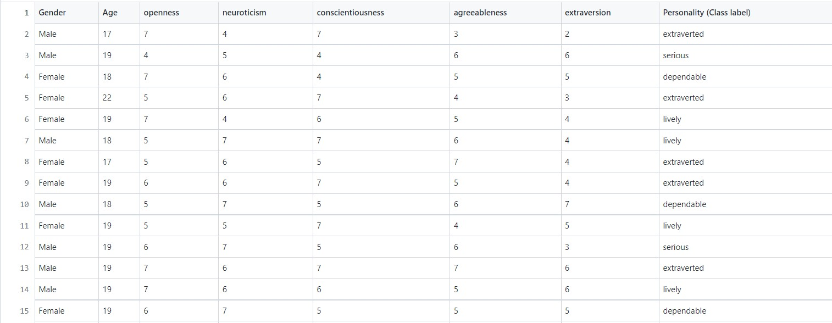

# 4. Architecture/Design

## 4.1 Overview

The proposed system or software is divided in three parts

* Candidates - Job Fit Analyzer portal
* Employees - Sorting and selecting candidates
* System - Asking questions and predicting marks with help of trained models

An electronic web-based form is created for the candidates on which they are asked questions. As it is web-based, it could be accessed easily on most of the devices.

After candidates submit their answers, the system automatically allot marks and sort them according to criteria set. This makes it easy for the employees to select candidates and makes the screening process smooth.

## 4.2 System Architecture

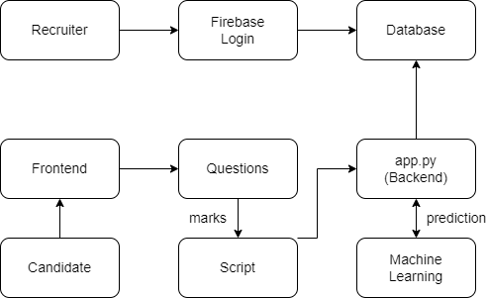

* Candidate connects to system frontend portal
* Candidate is displayed with the questions on the portal
* Employee login portal is integrated with firebase login for user authentication
* Marks are calculated automatically by the system using a script
* These marks are sent to backend server
* The server then sends this data to the ML models and the predicted results are stored in the database

## 4.3 Components Description

#### 4.3.1 Secured Login for the Recruiters

|  |  |
| --- | --- |
| **Identification** | Secured login screen |
| **Type** | Component/Form |
| **Purpose** | The login screen ensures that only employees can access the candidate data. |
| **Function** | It enables employees to see the applied candidates data, and make sure any unauthenticated person doesn't have access to it. |

|  |  |
| --- | --- |
| **Dependencies** | The following screen links to this screen:  ● Home Screen |
| **Interfaces** | The login form is located on the left half of the page, and designed to be easy to view. |
| **Resources** | Database Access Requirements: access to the violator information found in the appropriate database tables. |
| **Data** | The data for the login Screen is the email and password entered by the user. It is validated using the firebase authentication. |

#### 4.3.2 Extensive Questionnaire

|  |  |
| --- | --- |
| **Identification** | Extensive Questionnaire |
| **Type** | Component/Form |
| **Purpose** | To ask candidates questions and collect answers |
| **Function** | It is used to get answers to the questions asked by the system. These answers are used for ML model prediction. |
| **Dependencies** | The following screen links to this screen:  ● Register screen |
| **Interfaces** | The questions are displayed in an electronic HTML form |
| **Resources** | The questions are auto-generated by the system. |
| **Data** | The data for this screen are the questions and their respective answers submitted by the candidate. |

#### 4.3.3 Candidate Register

|  |  |
| --- | --- |
| **Identification** | Candidate register screen |
| **Type** | Component/Form |
| **Purpose** | To collect personal details of the candidate and register him. |
| **Function** | To collect details and store them in the system’s database. This database can be accessed by the employees. |
| **Dependencies** | The following screen links to this screen:  ● Home Screen |
| **Interfaces** | The details form is located on the left half of the page, and designed to be easy to view. |
| **Resources** | These details are used by employees to recognise and filter candidates. |
| **Data** | The data for this screen is the ID, name, age and gender entered by the user. |

#### 4.3.4 Filter by Category

|  |  |
| --- | --- |
| **Identification** | Category Filter screen |
| **Type** | Component/Page |
| **Purpose** | To see candidate data and filter them. |
| **Function** | It enables employees to see the applied candidates data and filter them according to different categories. |
| **Dependencies** | The following screen links to this screen:  ● Recruiter login screen |
| **Interfaces** | The login form is located on the left half of the page, and designed to be easy to view. |
| **Resources** | Different categories are allotted to candidates based on their marks |
| **Data** | The data for this screen is taken from a database. |

# 5. Description of Various Modules

|  |  |
| --- | --- |
| **Module** | **Description** |
| Backend | The backend server is made using python Flask API. SQLite is used as a database for storing data. |
| ML | Four algorithms are used including Logistic Regression, K Nearest Neighbours (KNN), Support Vector Classifier (SVC) and XGBoost, for the prediction of different personality traits. |
| Frontend | It is made using HTML, CSS, Bootstrap and JS. |
| Data Collection | The dataset is available on kaggle |

### Product Functions

* **Extensive Questionnaire**: multiple questions have been curated carefully for analysing the candidates’ big five traits (OCEAN).
* **Automatic scoring**: Our software calculates the marks of the candidates as soon as they submit their answers.
* **Easy access to candidates**: The candidates can access the system from any laptop or desktop with internet connectivity.
* **Ease the screening process:** The software allows employers to easily filter through a list of candidates and select the ones who fit into the required criteria.
* **Secured login**: A secured login page for employers to login and access the candidate database.

### Database Schema

For the proposed system the database used is SQLITE and for employee login firebase authentication is used

The schema used for SQLITE database is

* App_id
* Name
* Gender
* Age
* O, C, E, A, N (Openness, Conscientiousness, Extraversion, Agreeableness, Neuroticism)

● Personality

|  |  |  |  |
| --- | --- | --- | --- |
| **Table name** | **Field** | **Datatype** | **Primary** |
| Applicants | app_id | String | Yes |
| name | String | - |
| gender | String | - |
| age | Integer | - |
| o | Integer | - |
| c | Integer | - |
| e | Integer | - |
| a | Integer | - |
| n | Integer | - |
| personality | String | - |

# 

# 6. Implementation (Sample Code)

**Function for Plotting Confusion Matrix** def plotCM(y_true, y_pred, name = "Confusion Matrix"):

labels = unique_labels(y_test) table = pd.DataFrame(confusion_matrix(y_true, y_pred), columns = labels, index = labels)

sn.heatmap(table, annot = True, fmt = 'd', cmap = 'viridis') plt.gcf().axes[0].tick_params(colors = 'black') plt.gcf().axes[1].tick_params(colors = 'black') plt.title(name, color = 'black')

plt.xlabel('Predicted Label', color = 'black') plt.ylabel('True Label', color = 'black') plt.gcf().set_size_inches(10,6) plt.show()

**Instantiating the Algorithms** lr = LogisticRegression(multi_class='multinomial', solver='newton-cg',max_iter =1000) knn = KNN() svc = SVC() xgb = XGBClassifier() **Testing Logistic Regression** lr.fit(X_train, y_train) lr_pred = lr.predict(X_test) plotCM(y_test, lr_pred , 'Confusion Matrix for Logistic Regression') **Testing KNN**

knn.fit(X_train, y_train) knn_pred = knn.predict(X_test) plotCM(y_test, knn_pred , 'Confusion Matrix for KNN') **Testing SVC**

svc.fit(X_train, y_train) svc_pred = svc.predict(X_test) plotCM(y_test, svc_pred , 'Confusion Matrix for SVC')

### Testing XGBoost

xgb.fit(X_train, y_train) xgb_pred = xgb.predict(X_test) plotCM(y_test, xgb_pred , 'Confusion Matrix for XGBoost') **Calculating F1 Scores and Plotting the Graph** algos = ['Logistic Regression', 'KNN', 'SVC', 'XGBoost']

f1_scores = [f1_score(y_test, lr_pred, average='weighted'), f1_score(y_test, knn_pred, average='weighted'), f1_score(y_test, svc_pred, average='weighted'), f1_score(y_test, xgb_pred, average='weighted')] ypos = np.array([0,1,2,3]) plt.xticks(ypos, algos) plt.bar(ypos, f1_scores) plt.gcf().axes[0].tick_params(colors = 'black') plt.title('F1 Scores vs Algos', color = 'black') plt.xlabel('Algorithms', color = 'black') plt.ylabel('F1 Scores', color = 'black') plt.gcf().set_size_inches(10,6) plt.show()

### Final Implementation of Model into Web App from os import name

from flask import Flask, render_template, url_for, flash, redirect, request from flask_sqlalchemy import SQLAlchemy from marks import calculate import pickle

import numpy as np with open ('personality_prediction_lr', 'rb') as f:

model = pickle.load(f) app = Flask(__name__)

app.config['SQLALCHEMY_DATABASE_URI'] = 'sqlite:///Applicants.db' app.config['SQLALCHEMY_TRACK_MODIFICATIONS'] = False db = SQLAlchemy(app)

15 class Applicants(db.Model):

app_id = db.Column(db.String(100), primary_key = True) name =

db.Column(db.String(100), nullable = False) gender = db.Column(db.String(10), nullable = False) age = db.Column(db.Integer, nullable = False) o = db.Column(db.Integer, nullable = False) n = db.Column(db.Integer, nullable = False) c = db.Column(db.Integer, nullable = False) a = db.Column(db.Integer, nullable = False) e = db.Column(db.Integer, nullable = False)

Personality = db.Column(db.String(20), nullable = False) def __repr__(self) -> str:

return f"{self.app_id}-{self.name} - {self.gender} - {self.age} - {self.o} - {self.n} - {self.c} -

{self.a} - {self.e} - {self.Personality}" def __init__(self, app_id, name, gender, age, o, n, c, a, e, Personality): self.app_id = app_id self.name = name

self.gender = gender self.age = age self.o = o self.n = n self.c = c self.a = a self.e = e self.Personality = Personality

@app.route('/') def index():

return render_template("index.html")

16

@app.route('/register', methods = ['GET', 'POST']) def register(): if request.method == 'POST': app_id = request.form['id1'] name = request.form['name'] gender = request.form['gender'] age = request.form['age'] detail = app_id + "-" + name + "-" + gender + "-" + age return redirect(url_for("quiz", details = detail))

return render_template("register.html")

@app.route('/quiz/<details>', methods = ['GET', 'POST']) def quiz(details): if request.method == 'POST':

ans = [] ans.append(request.form.getlist('mycheckbox')[0]) ans.append(request.form.getlist('mycheckbox1')[0]) ans.append(request.form.getlist('mycheckbox2')[0]) ans.append(request.form.getlist('mycheckbox3')[0]) ans.append(request.form.getlist('mycheckbox4')[0]) ans.append(request.form.getlist('mycheckbox5')[0]) ans.append(request.form.getlist('mycheckbox6')[0]) ans.append(request.form.getlist('mycheckbox7')[0]) ans.append(request.form.getlist('mycheckbox8')[0]) ans.append(request.form.getlist('mycheckbox9')[0]) essentials = details.split('-') o1, c1, e1, a1, n1 = calculate(ans) data = [] if(essentials[2].lower()=='male'):

data.append(1) else: data.append(0) data.append(int(essentials[3])) data.append(o1) data.append(n1) data.append(c1) data.append(a1) data.append(e1) data = np.array(data).reshape(1,7) p = model.predict(data)

apply = Applicants(app_id = essentials[0], name = essentials[1], gender = essentials[2], age = int(essentials[3]),o = o1,n= n1,c= c1,a= a1,e = e1, Personality = p[0]) db.session.add(apply) db.session.commit() return redirect(url_for("submit")) return render_template("quiz.html")

@app.route('/submit') def submit():

return render_template("submit.html")

@app.route('/recruiter-login', methods = ['GET', 'POST']) def recruiter(): if request.method == 'POST':

return render_template("recruiter.html")

return render_template("recruiter.html")

@app.route('/data')

18

def data():

apply = Applicants.query.all() return render_template("data.html", applicants = apply) if __name__=="__main__":

app.run(debug = True, port = 4000)

**Function to calculate the marks from the questionnaire** def calculate(answers):

o = 0 c = 0 e = 0 a = 0 n = 0 #for ques 1 temp0 = int(answers[0]) n+=temp0

#for ques 2 temp1 = int(answers[1]) c+=temp1

#for ques 3

temp2 = int(answers[2]) o+=(6-temp2) #for ques 4 temp3 = int(answers[3]) e+=temp3

#for ques 5 temp4 = int(answers[4]) c+=(6-temp4)

#for ques 6 19 temp5 = int(answers[5]) a+=(6-temp5) #for ques 7 temp6 = int(answers[6]) n+=(6-temp6) #for ques 8 temp7 = int(answers[7]) e+=temp7

#for ques 9 temp8 = int(answers[8]) o+=temp8

#for ques 10

temp9 = int(answers[9]) a+=temp9

return o,c,e,a,n

# 7. Testing (ALL Screen Snapshots)

## 7.1 Phase 1 Comparison of Various Models

Four algorithms were used in the first stage of development including Logistic Regression, K Nearest Neighbours (KNN), Support Vector Classifier (SVC) and XGBoost. To compare these various models, Confusion Matrix and F1 Score measures were employed. In both the metric cases, Logistic Regression turned out to perform the best for our dataset. F1 score for Logistic Regression turned out to be approximately 0.8 which was quite good. Depending on the aforementioned results, we decided to move forward and use logistic regression as the building model for our project. Here are the confusion matrices for each type and the graph for final comparison.

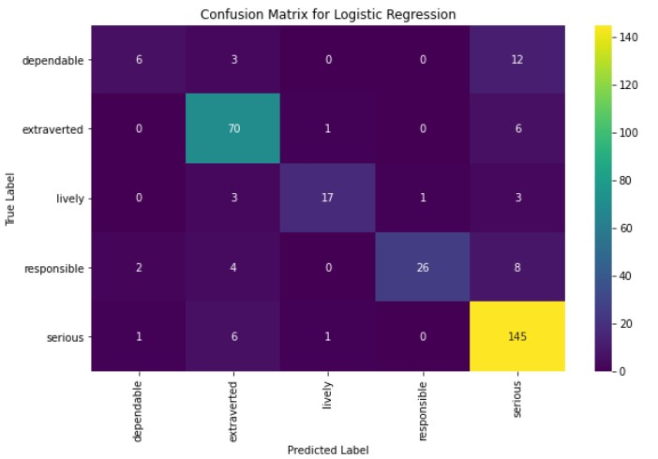

Figure 1 Confusion Matrix for Logistic Regression

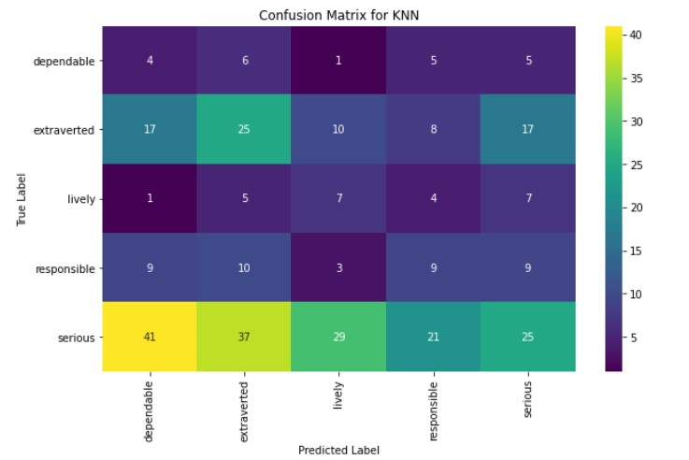

Figure 2 Confusion Matrix for KNN

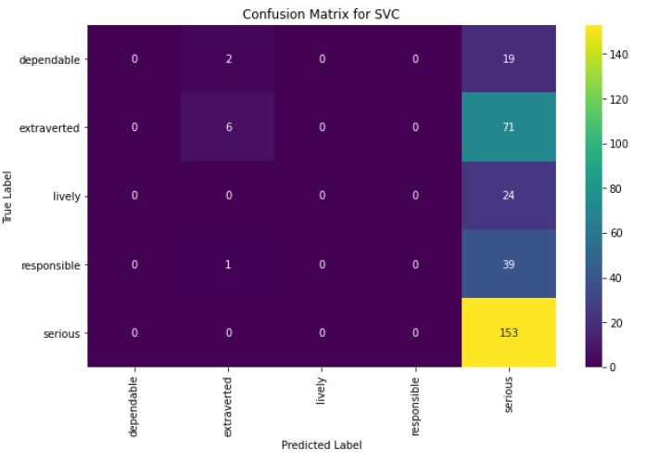

Figure 3 Confusion Matrix for SVC

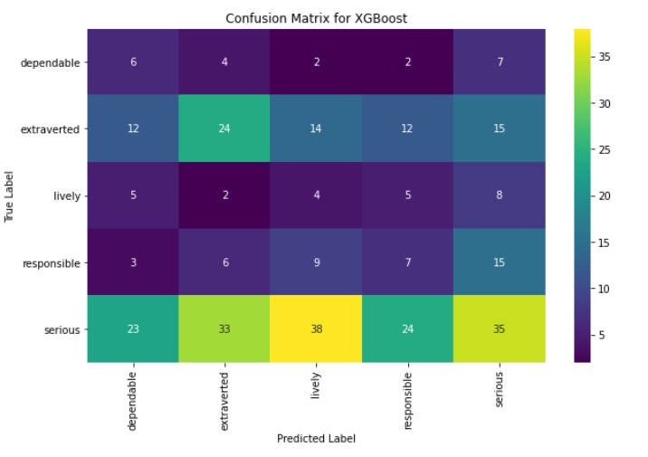

Figure 4 Confusion Matrix for XGBoost

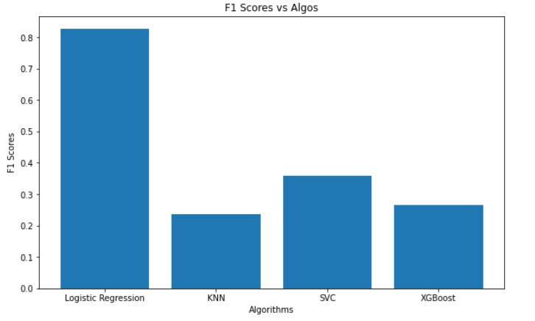

Figure 5 Comparison of F1 Scores

## 7.2 Phase 2 Implementation of the Chosen Model

In the second stage, we implemented our Logistic Regression model and integrated the same into our Web Application using Flask. We also created a database in SQLite using Flask SQLAlchemy.

**Dataset Description**:

**Attribute Description**: No. of attributes are 7 as listed below.

|  |  |  |  |
| --- | --- | --- | --- |
| **S. No** | **Attribute** | **Type** | **Range** |
| 1 | Gender | Nominal | Male/Female |
| 2 | Age | Numeric | 17-28 |
| 3 | Openness | Numeric | 1-8 |
| 4 | Neuroticism | Numeric | 1-8 |
| 5 | Conscientiousness | Numeric | 1-8 |
| 6 | Agreeableness | Numeric | 1-8 |
| 7 | Extraversion | Numeric | 1-8 |

**Class label description:**

### No. of class labels: 5

**Type**: Nominal **Class Labels:**

* Extraverted
* Serious
* Responsible

● Lively

* Dependable

## 7.3 Test cases

|  |  |  |  |  |  |
| --- | --- | --- | --- | --- | --- |
| **Test case** | **Objective** | **Pre-requisite** | **Steps** | **Output** | **Status** |
| TC1 | Index/Home page of the software/webap p | Flask server must be started | Open browser  and fetch “/” in the url | Home page  is displayed | PASS |

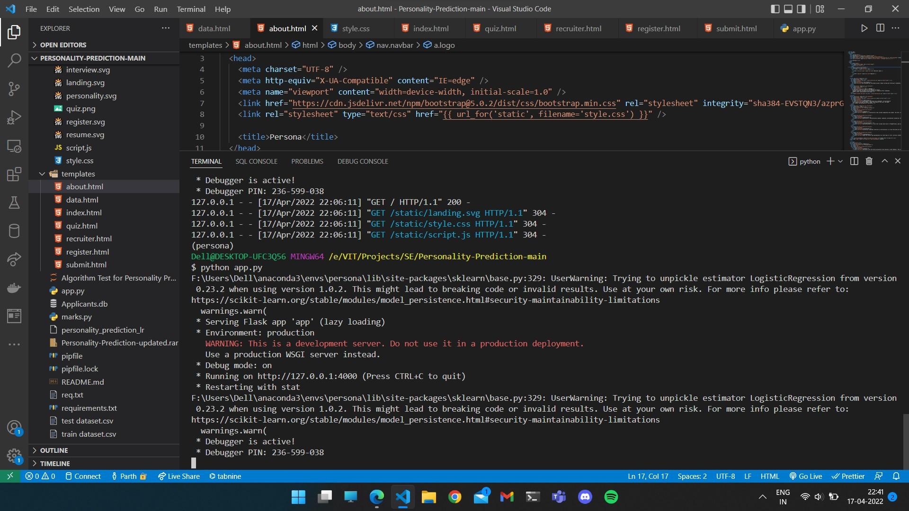

|  |  |  |  |  |  |
| --- | --- | --- | --- | --- | --- |
| **Test case** | **Objective** | **Pre-requisite** | **Steps** | **Output** | **Status** |
|  | Opening Learn More page | Learn more button should be present | Open home  page and click on learn more button in the left side pan. | Learn more page is displayed  It shows about page, scoring criteria and personalities description | PASS |

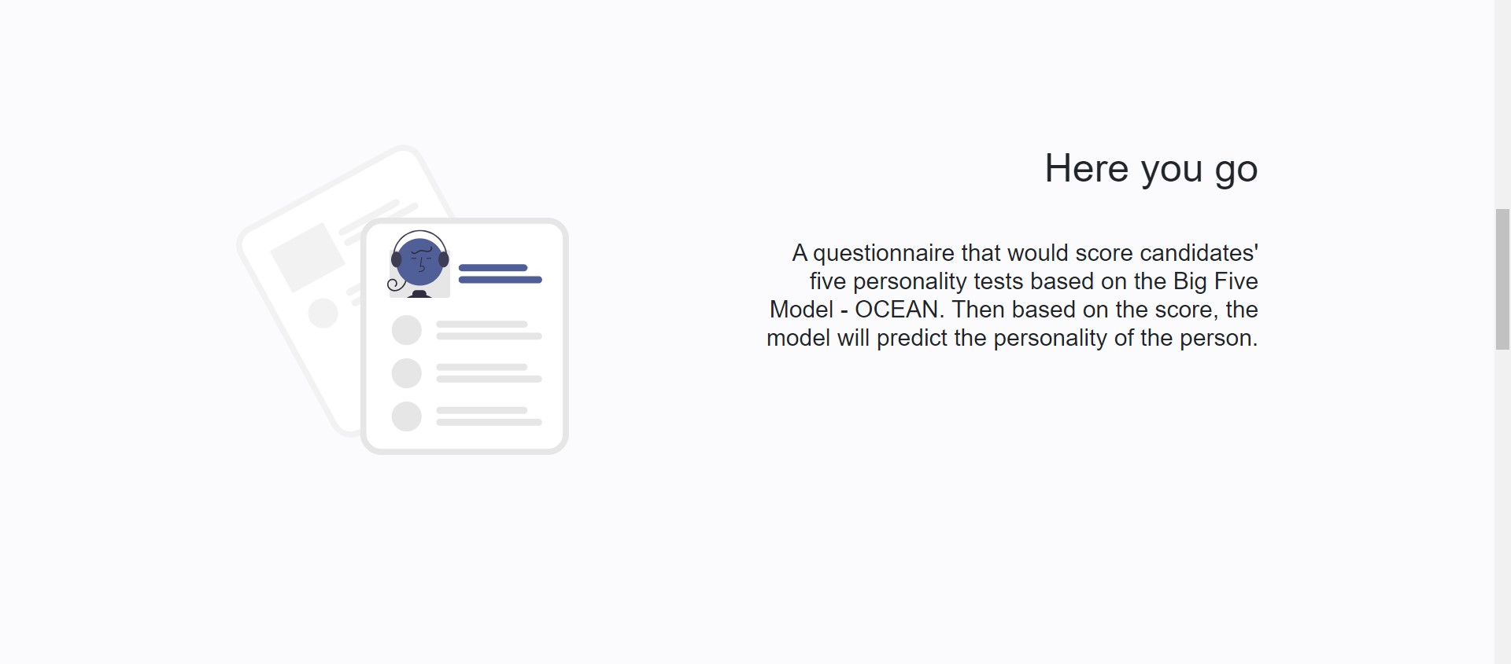

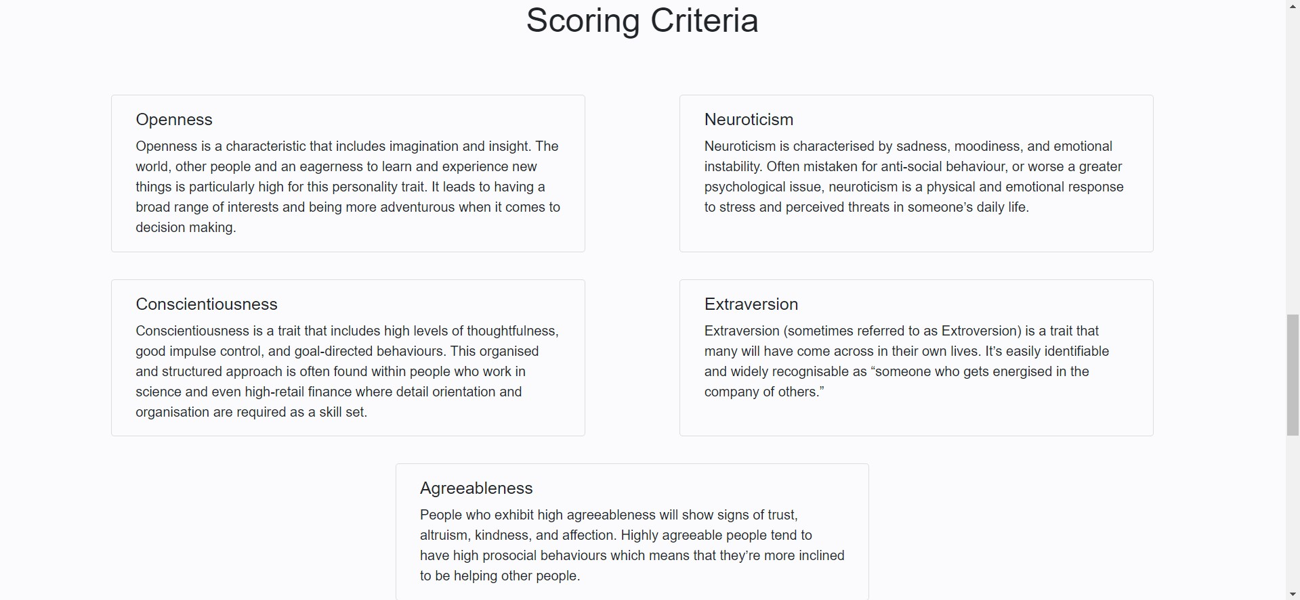

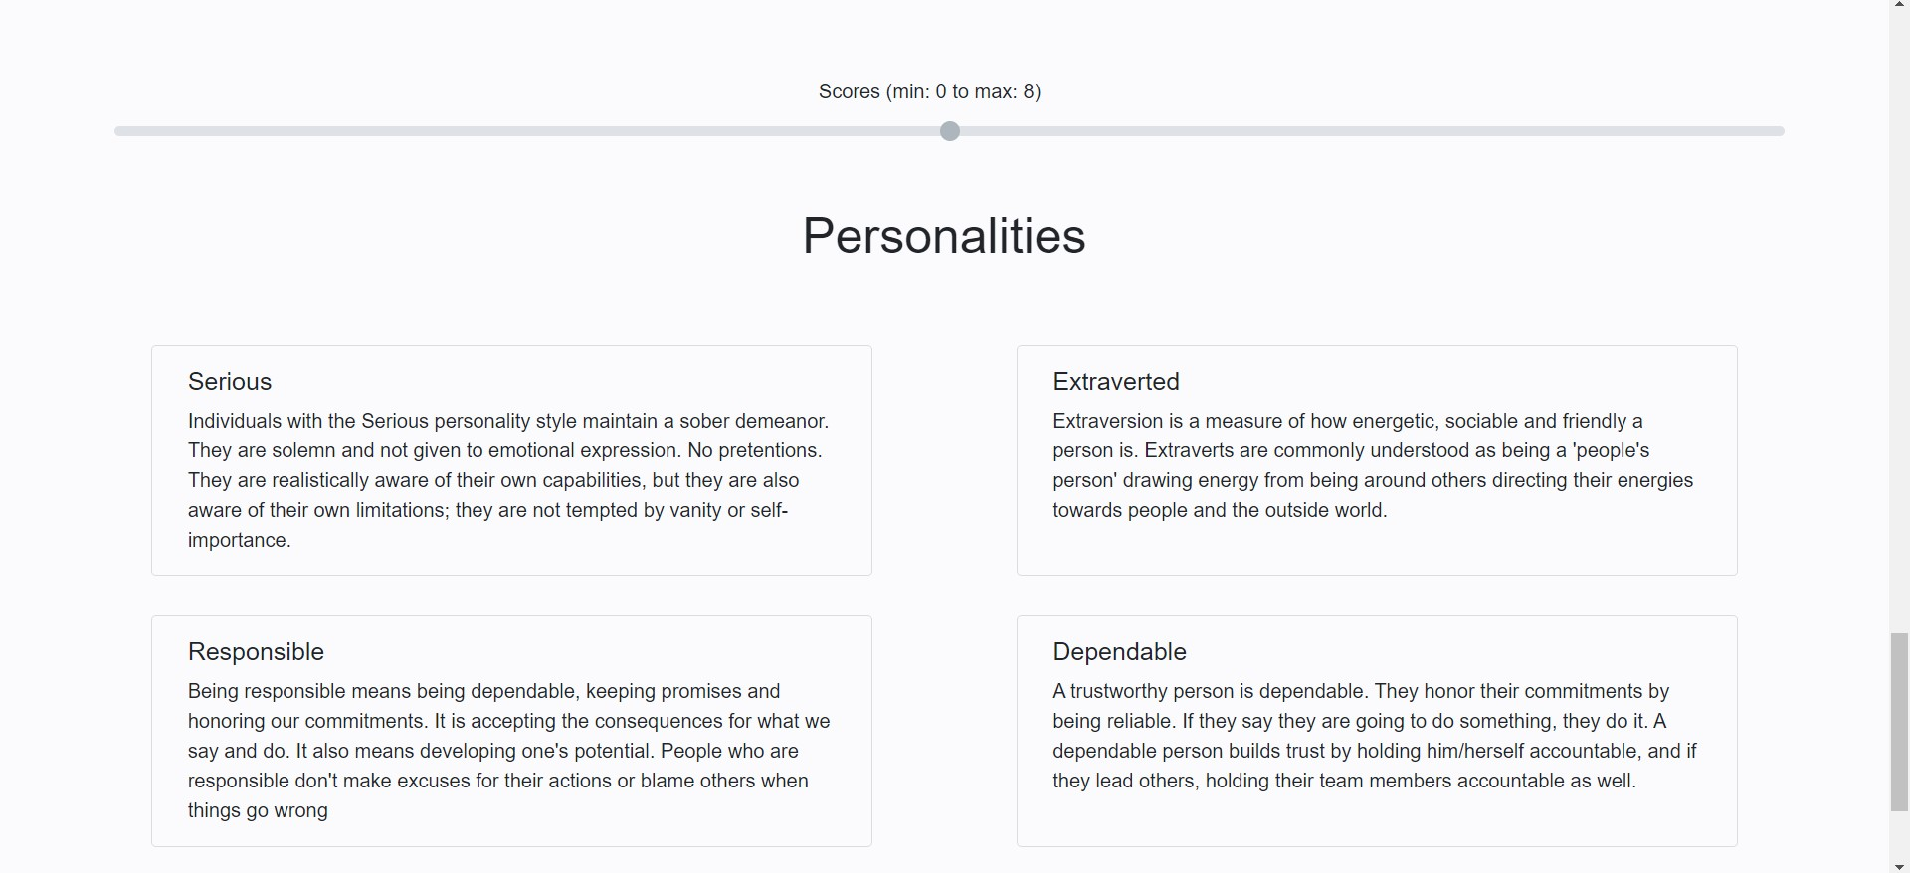

|  |  |  |  |  |  |
| --- | --- | --- | --- | --- | --- |
| **Test case** | **Objective** | **Pre-requisite** | **Steps** | **Output** | **Status** |
| TC3 | Candidate register page | Register button should be present | Open home page  Click on register button in the left side pan or on the top right corner of home page. | Candidate register page is displayed  It shows a form in the left pan and an SVG  illustration on the right.  Form  includes four input field and a submit button | PASS |

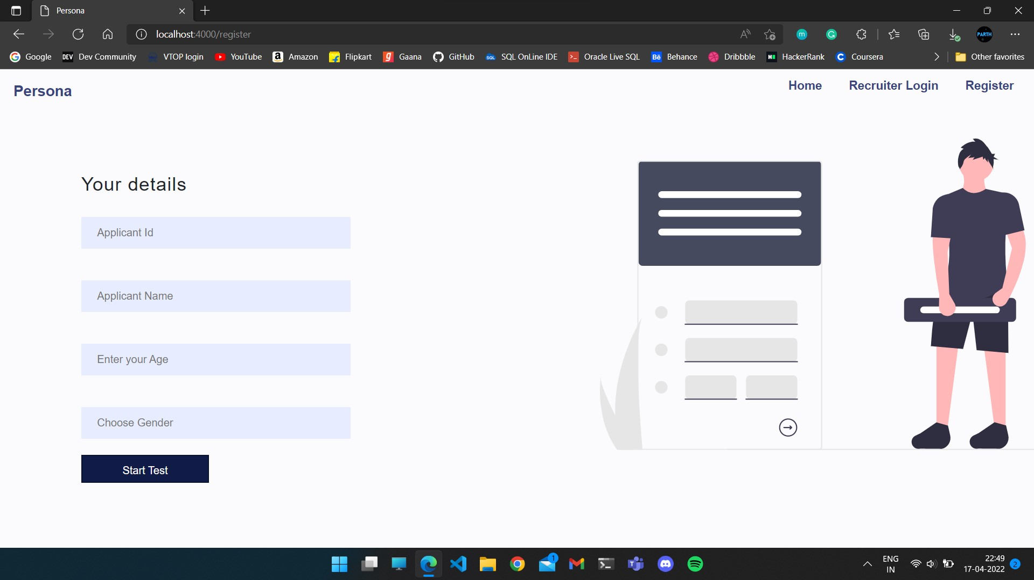

|  |  |  |  |  |  |
| --- | --- | --- | --- | --- | --- |
| **Test case** | **Objective** | **Pre-requisite** | **Steps** | **Output** | **Status** |
| TC4 | Recruiter login page  Valid email and password | Register button should be present | Open home page  Click on register button in the left side pan or on the top right corner of home page.  Check with both valid and invalid emails  Check with valid and invalid passwords | Candidate register page is displayed  It shows a form in the left pan and an SVG  illustration on the right.  Form  includes four input field and a submit button  Shows alert for invalid email and password | PASS |

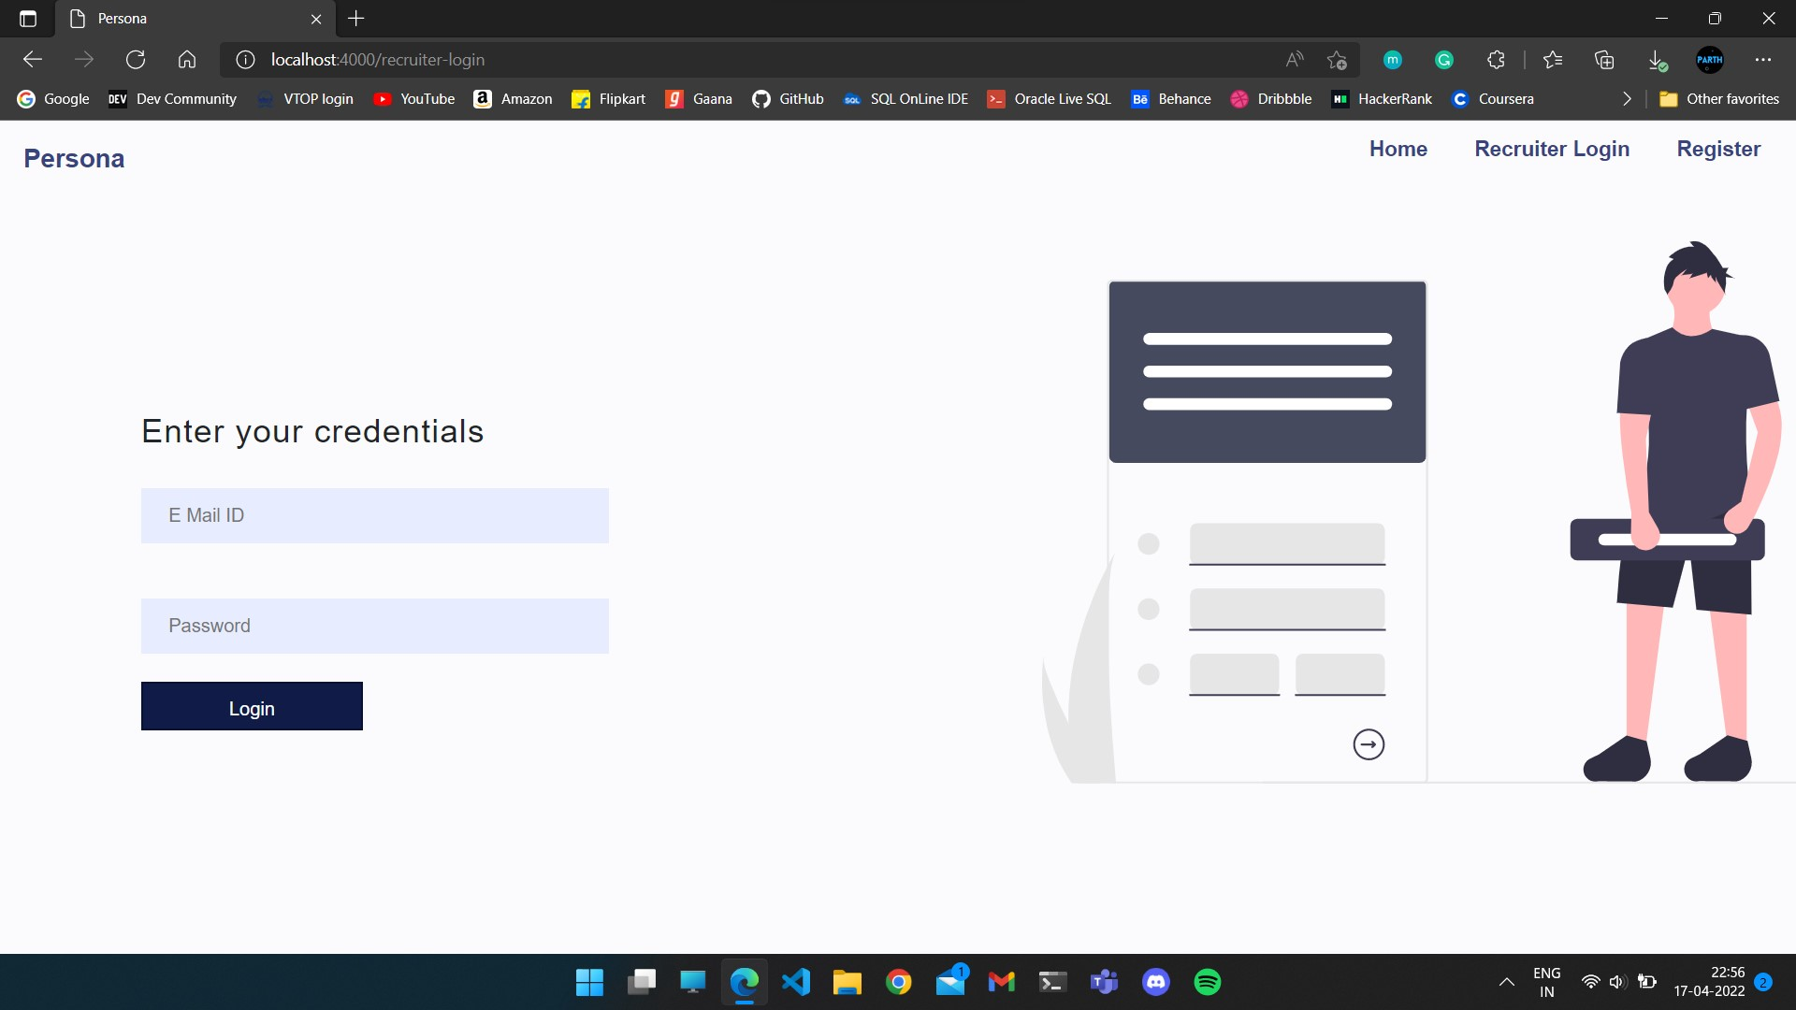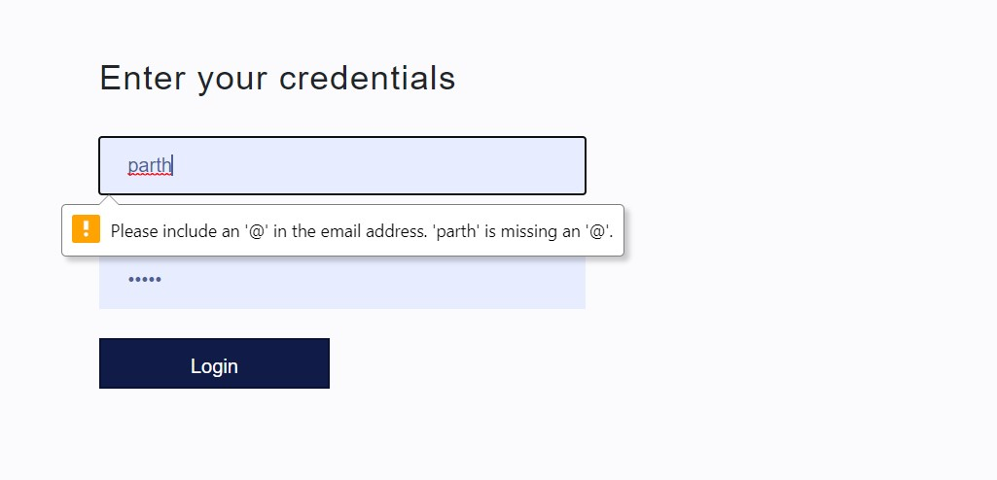

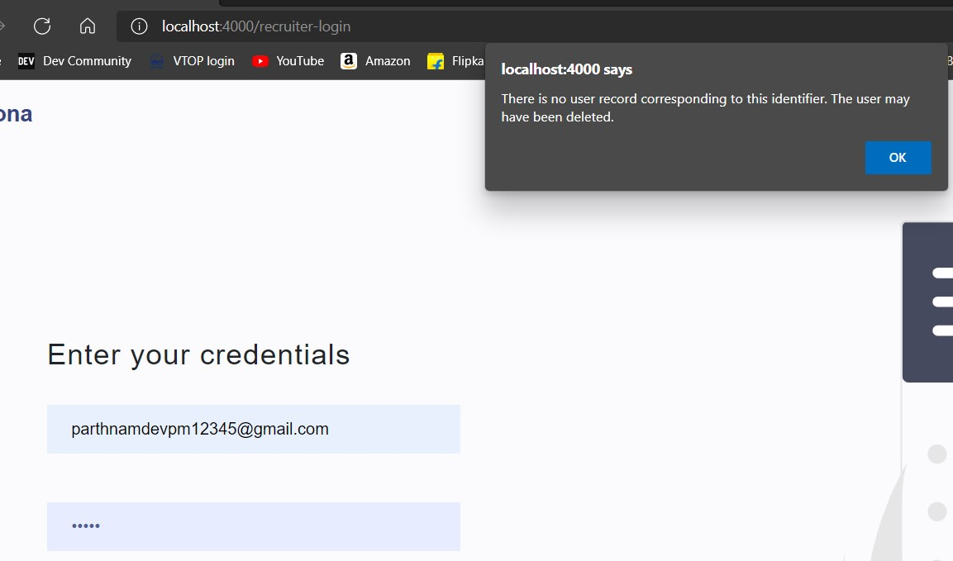

|  |  |  |  |  |  |
| --- | --- | --- | --- | --- | --- |
| **Test case** | **Objective** | **Pre-requisite** | **Steps** | **Output** | **Status** |
| TC5 | Quiz/Questionnaire page | User authentication via candidate register page | Register as a candidate  Submit the form | Quiz/questio nnaire page is displayed  Left side includes 10 questions  Right pan shows an  SVG  illustration  All questions have 5 options and could be answered using radio buttons. | PASS |

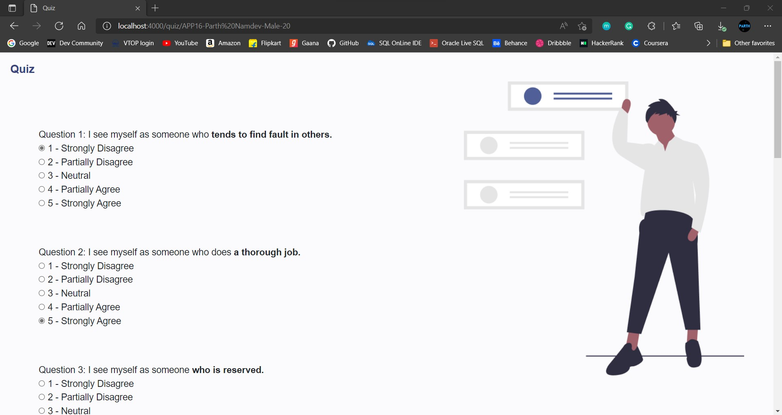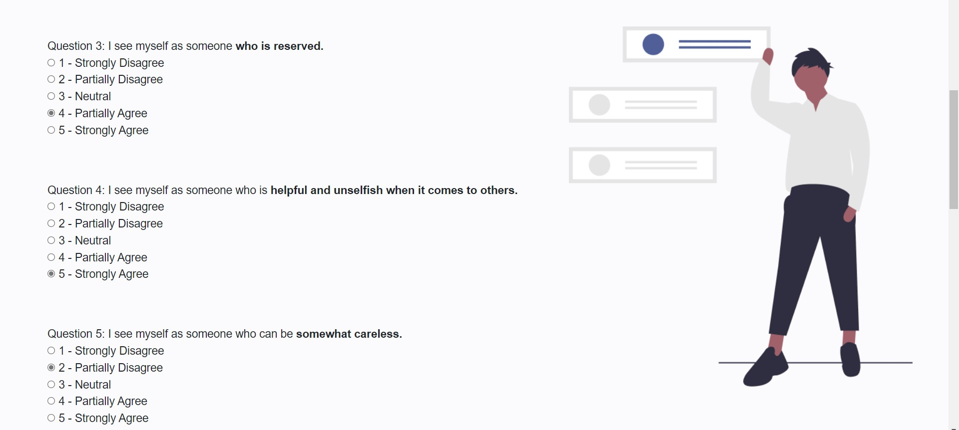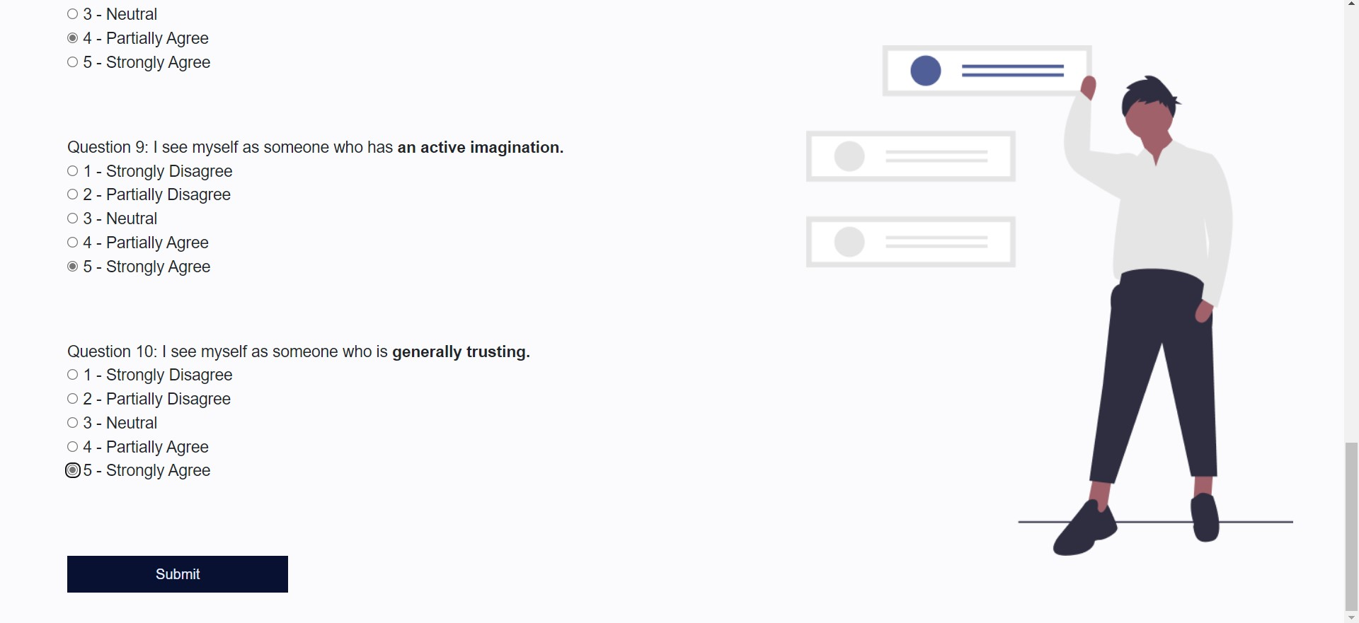

|  |  |  |  |  |  |
| --- | --- | --- | --- | --- | --- |
| **Test case** | **Objective** | **Pre-requisite** | **Steps** | **Output** | **Status** |
| TC6 | Response submitted page | Quiz to be submitted | Register and open quiz page  Answer all questions  Submit the form | Success/sub mitted message displayed in  center of the page | PASS |

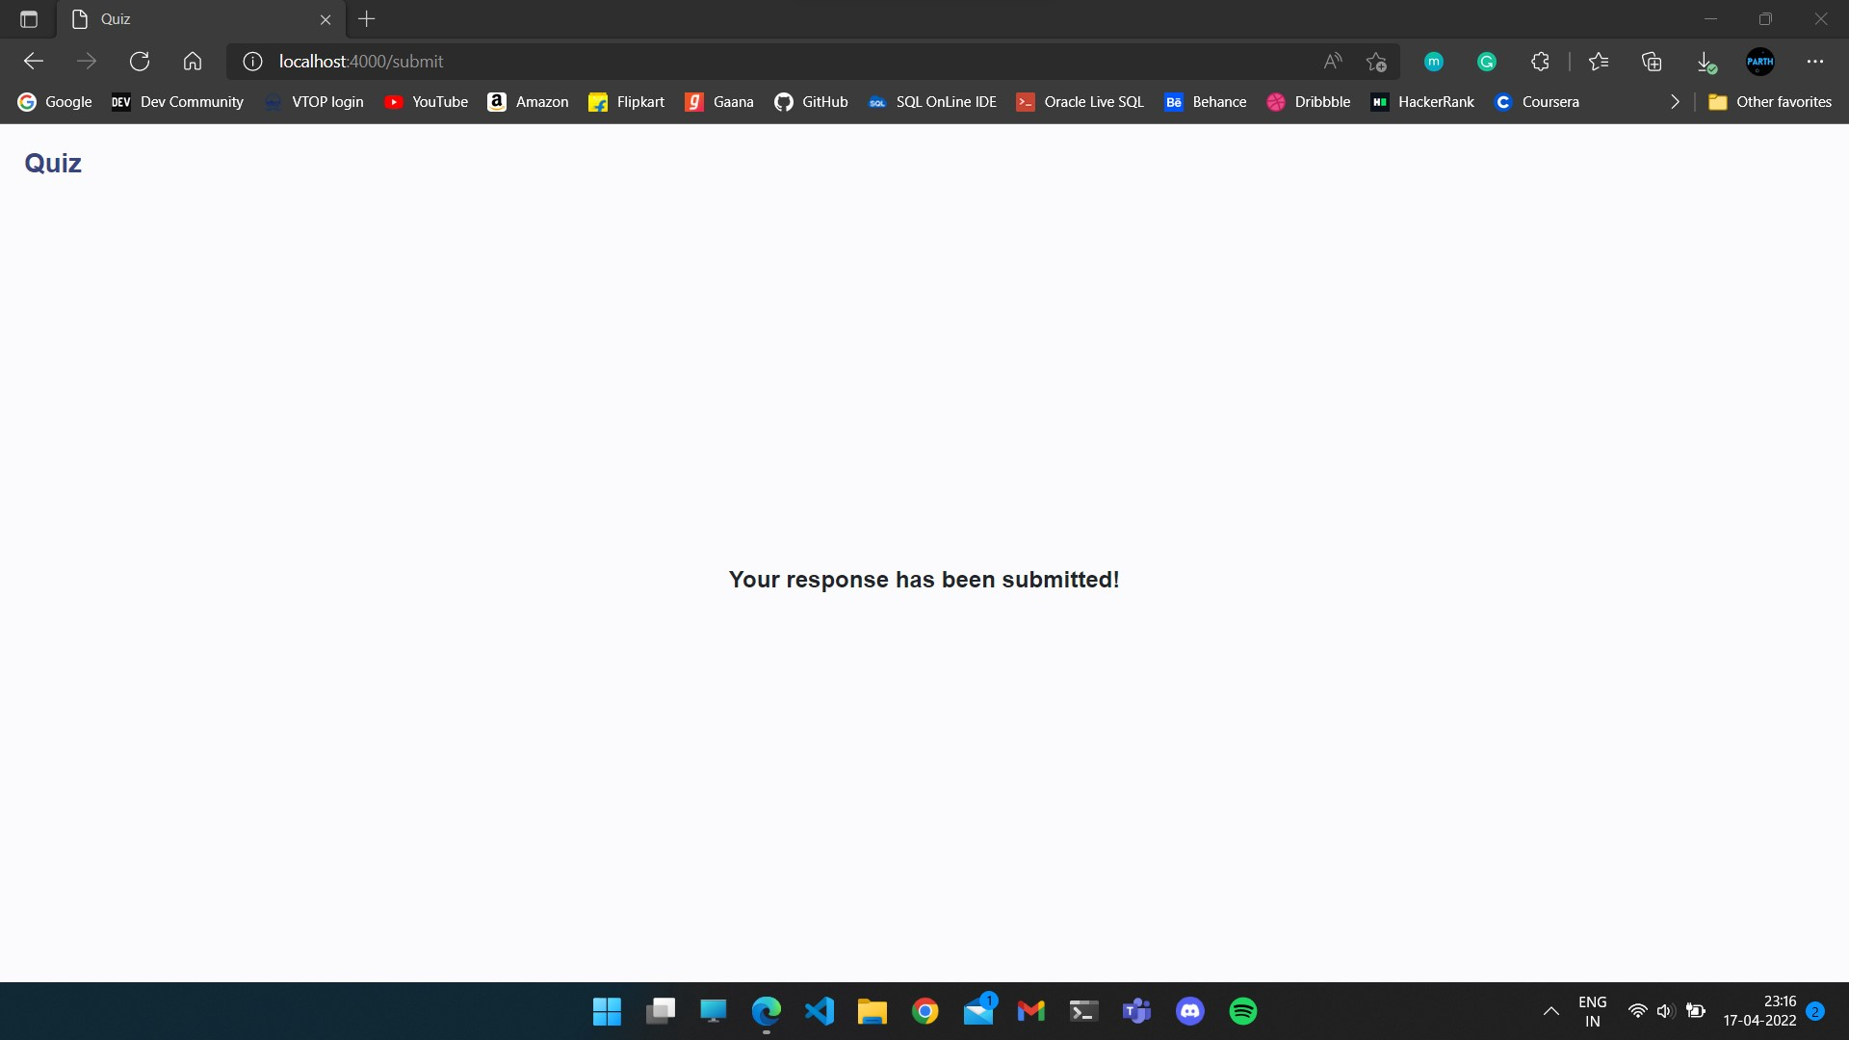

|  |  |  |  |  |  |
| --- | --- | --- | --- | --- | --- |
| **Test case** | **Objective** | **Pre-requisite** | **Steps** | **Output** | **Status** |
| TC7 | Candidates’ data page | Recruiter login/authentication | Open recruiter login page  Input valid credentials  Submit form  To filter candidates, a search category  in the field given | A data table is displayed that includes or shows all candidates’ data  It has all five big traits’ scores and personality category for each | PASS |

|  |  |  |  |  |  |
| --- | --- | --- | --- | --- | --- |
|  |  |  | To send mail for hiring, press corresponding button | candidate  Buttons for mail/hire is given in the last column of each row  Know more  button given for scoring criteria and personality categorisation/classification |  |

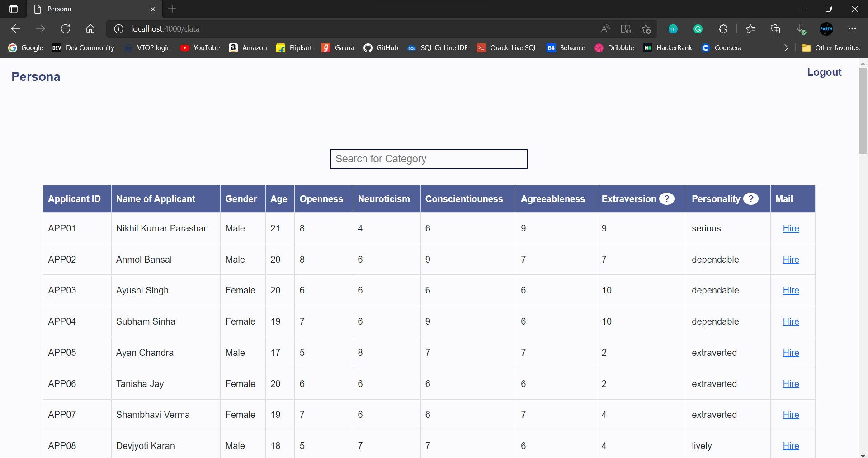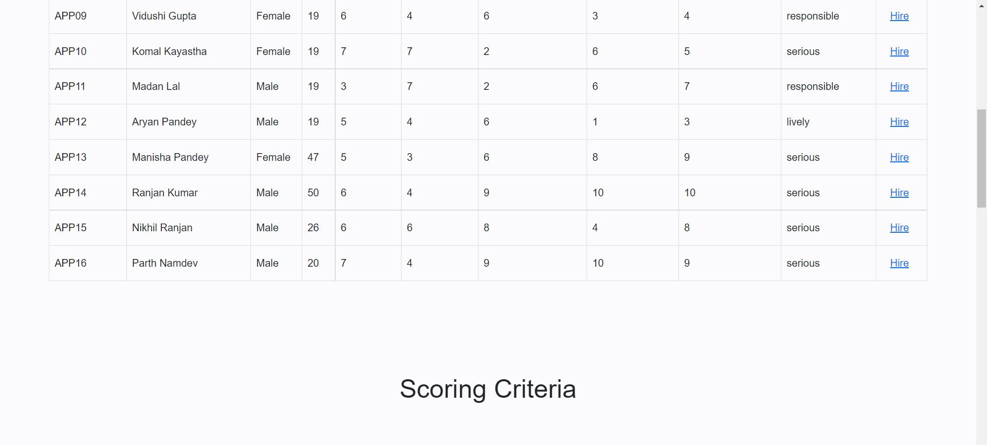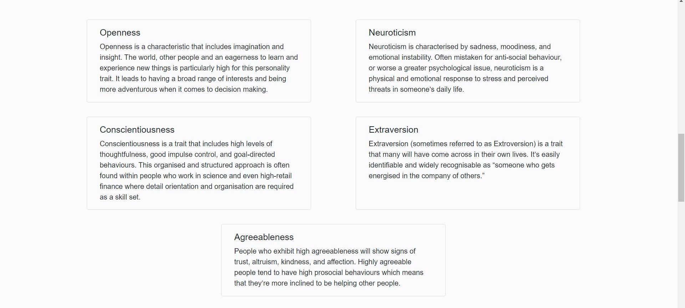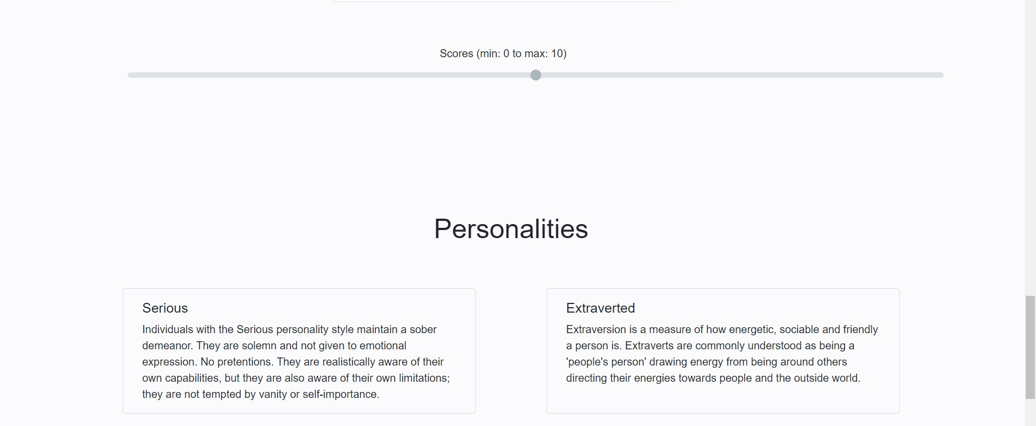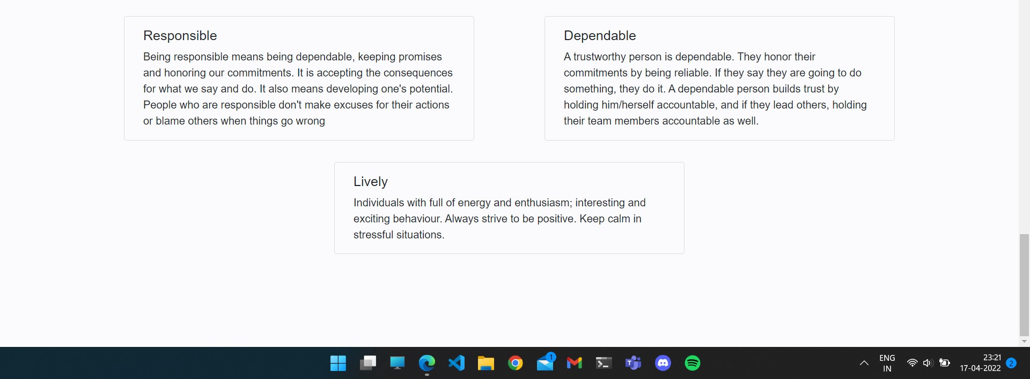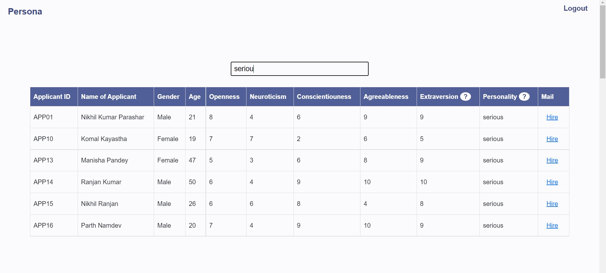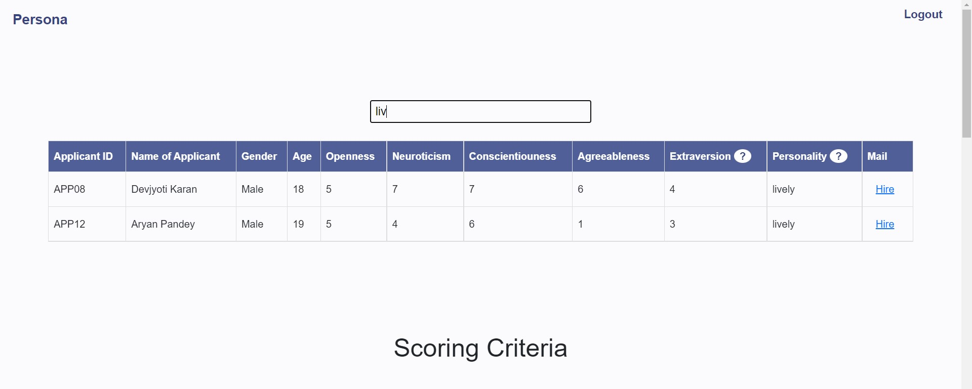

|  |  |  |  |  |  |
| --- | --- | --- | --- | --- | --- |
| **Test case** | **Objective** | **Pre-requisite** | **Steps** | **Output** | **Status** |
| TC8 | Answering all questions as neutral | Quiz page open | Submit all answers as neutral | Submit page is displayed  The  personality category shows  “serious”.  The person thinks deeply  for all different cases, hence marked as “serious”. | PASS |

# 

# 8. Conclusion and Future Enhancements

We believe that our model can be helpful for recruiters around the globe to identify the perfect candidate for their job in a quick manner. Logistic Regression and the Big 5 Model can be useful in identifying the personality of an individual. Further, we would like to enhance the model by incorporating a portal for job seekers to identify their strengths and weaknesses and also find other applications of our Personality Prediction Model - Persona.

**Team Members Contribution**

|  |  |  |
| --- | --- | --- |
| **Registration Number** | **Name** | **Contribution / Role in this**  **Project** |
| 21BCE5634 | Pardha Saradhi Raju | Backend |
| 21BCE1037 | Potnuru Jayanth | ML |
| 21BCE5376 | Jaini Karhtik | Frontend |
| 21BCE1690 | Shaik Ashfaaq Hamja | Backend & ML |
| 21BCE5855 | Rajamalla Ananya Tej | Data Collection |

## 

## References

1. M. M. Tadesse, H. Lin, B. Xu and L. Yang, "Personality Predictions Based on User Behavior on the Facebook Social Media Platform," in IEEE Access, vol. 6, pp. 61959-61969, 2018, doi: 10.1109/ACCESS.2018.2876502.
2. Maliki, I., & Sidik, M. A. (2020). Personality prediction system based on signatures using machine learning. *IOP Conference Series: Materials Science and Engineering*, *879*(1),

012068. https://doi.org/10.1088/1757-899x/879/1/012068

1. Hetal Vora , Mamta Bhamare , Dr. K. Ashok Kumar, 2020, Personality Prediction from

Social Media Text: An Overview, INTERNATIONAL JOURNAL OF ENGINEERING

RESEARCH & TECHNOLOGY (IJERT) Volume 09, Issue 05 (May 2020)

1. Rout, Jayashree & Bagade, Sudhir & Yede, Pooja & Patil, Nirmiti. (2019). Personality Evaluation and CV Analysis using Machine Learning Algorithm. International Journal of Computer Sciences and Engineering. 7. 1852-1857. 10.26438/ijcse/v7i5.18521857.
2. Ombhase, Manasi & Gogate, Prajakata & Patil, Tejas & Nair, Karan & Hegde, Prof.

(2017). Automated Personality Classification Using Data Mining Techniques.

10.13140/RG.2.2.35949.59363.

1. Dehghanan, Hamed & Abdollahi, Hadi & Rezaei, Mohammad. (2014). A study on effect of big five personality traits on emotional intelligence. Management Science Letters. 4. 10.5267/j.msl.2014.4.016.
2. Varvel, Tricia & Adams, Stephanie & Pridie, Shelby. (2003). A Study of the Effect of the Myers-Briggs Type Indicator on Team Effectiveness. ASEE Annual Conference Proceedings.

[8] Ali, Jehad & Khan, Rehanullah & Ahmad, Nasir & Maqsood, Imran. (2012). Random

Forests and Decision Trees. International Journal of Computer Science Issues(IJCSI). 9.

1. Evgeniou, T., Pontil, M. (2001). Support Vector Machines: Theory and Applications. In: Paliouras, G., Karkaletsis, V., Spyropoulos, C.D. (eds) Machine Learning and Its Applications. ACAI 1999. Lecture Notes in Computer Science(), vol 2049. Springer, Berlin, Heidelberg. <https://doi.org/10.1007/3-540-44673-7_12>
2. Durupinar, F., Pelechano, N., Allbeck, J. M., Gudukbay, U., &amp; Badler, N. I. (2011). How the ocean personality model affects the perception of crowds. IEEE Computer Graphics and Applications, 31(3), 22–31. https://doi.org/10.1109/mcg.2009.105
3. Natekin, Alexey & Knoll, Alois. (2013). Gradient Boosting Machines, A Tutorial.

Frontiers in neurorobotics. 7. 21. 10.3389/fnbot.2013.00021.

1. Rohani, Afrina R., "A Survey of the Big Five Personality Traits Among Elementary Teachers" (2017). Honors Undergraduate Theses. 257
2. Aslam, Fankar & Mohammed, Hawa & Lokhande, Prashant. (2015). Efficient Way Of Web Development Using Python And Flask.. International Journal of Advanced Research in Computer Science. 6.
3. Randles, B. M., Pasquetto, I. V., Golshan, M. S., & Borgman, C. L. (2017). Using the Jupyter notebook as a tool for Open science: An empirical study. *2017 ACM/IEEE Joint*

*Conference on Digital Libraries (JCDL)*. https://doi.org/10.1109/jcdl.2017.7991618

1. Rish, Irina. (2001). An Empirical Study of the Naïve Bayes Classifier. IJCAI 2001 Work Empir Methods Artif Intell. 3.
2. Kaviani, Pouria & Dhotre, Sunita. (2017). Short Survey on Naive Bayes Algorithm. International Journal of Advance Research in Computer Science and Management. 04.
3. Song, Shuang & Chaudhuri, Kamalika & Sarwate, Anand. (2013). Stochastic gradient descent with differentially private updates. 2013 IEEE Global Conference on Signal and

Information Processing, GlobalSIP 2013 - Proceedings. 245-248.

10.1109/GlobalSIP.2013.6736861.